Topic |  |  |  | Independent Learning and  homework tasks
 |  |  |  | MyMaths | CorbettMaths.com
Identify congruent triangles and shapes |  |  |  | Shape, Scale and Similarity | Video 66- 7
Using congruent triangles for geometric proof |  |  |  |  | Video 66- 7
Calculating speed, distance, time |  |  |  | Shape, Measures, Speed | Video 299
Constructing and interpreting distance time graphs |  |  |  | Algebra, Graphs, Distance Time Graphs | Video 171
Constructing and interpreting other real life graphs, including rate being gradient of a linear graph |  |  |  | Algebra, Graphs, Real Life Graphs | Video 288, 388a
Solving problems involving rate of change |  |  |  | Algebra, Graphs, Real Life Graphs | Video 81 - 83
Knowledge Organiser
Trinity Term 2 Set 1 Year 9

Maths Support Attend KS3 Maths Clinic every Friday lunch time for extra help and support.
Stretch and Challenge:
1) Practise UKMT Intermediate Maths Challenge Past papers on ukmt.org.uk
2) Set up an account on parallel.org.uk website, using your school email address and use teacher code “ha52kh”
3) Attend Puzzle Club one lunch time each week

Trinity Term 2 Knowledge Scan for full list of Year 9 Maths facts
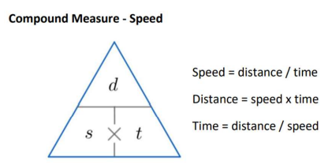

Knowledge Organiser

Trinity Term 2 Set 1 3rd Year

Topic |  |  |  | Independent Learning and  homework tasks
 |  |  |  | MyMaths | CorbettMaths.com
Identify congruent triangles and shapes |  |  |  | Shape, Scale and Similarity | Video 66- 7
Using congruent triangles for geometric proof |  |  |  |  | Video 66- 7
Calculating speed, distance, time |  |  |  | Shape, Measures, Speed | Video 299
Constructing and interpreting distance time graphs |  |  |  | Algebra, Graphs, Distance Time Graphs | Video 171
Constructing and interpreting other real life graphs, including rate being gradient of a linear graph |  |  |  | Algebra, Graphs, Real Life Graphs | Video 288, 388a
Solving problems involving rate of change |  |  |  | Algebra, Graphs, Real Life Graphs | Video 81 - 83
Maths Support Attend KS3 Maths Clinic every Friday lunch time for extra help and support.
Stretch and Challenge:
1) Practise UKMT Intermediate Maths Challenge Past papers on ukmt.org.uk
2) Set up an account on parallel.org.uk website, using your school email address and use teacher code “ha52kh”
3) Attend Puzzle Club one lunch time each week

Trinity Term 2 Knowledge Scan for full list of 3rd Year Maths facts

