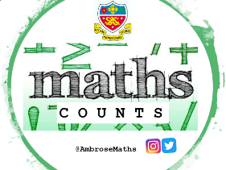
Knowledge Organiser
Autumn Term 2 Set 3c Year 11
Topic | Self-Assessment | Independent Learning and  homework tasks
 |  | MyMaths | CorbettMaths.com
Factorising quadratic expressions, of the form ax²+bx+c, including the difference of two squares. |  | Algebra, Algebra Manipulation, Factorising Quadratics | Quadratics (factorising) video 266
Solving quadratic equations by factorising. |  | Algebra, Equations – quadratics, Quadratic Equations 2 | Video 266
Identifying triangles are congruent.
Using congruent triangles for geometric proofs. |  | Shape, Angles, Angle Proof | Video 366
Understanding properties of similar shapes. |  | Shape, Scale and Similarity
Using similar triangles to calculate lengths of unknown sides. |  | Shape, Scale and Similarity | Video 294
Calculating unknown sides and angles of right-angled triangles using sine, cosine and tangent. |  | Shape, Trigonometry | Video 330-1
Know the exact values of sinθ and cosθ and tanθ for θ = 0°, 30°, 45° , 60° and 90° |  | Shape, Trigonometry | Video 341
Drawing and interpreting histograms.  Calculating frequency density. |  | Data, Presenting Data, Histograms | Video 157 - 8

Extra practice and support :
- Set up an account on parallel.org.uk website, using your school email address and use teacher code “ha52kh”

- Attend Maths Clinic one lunch time each week

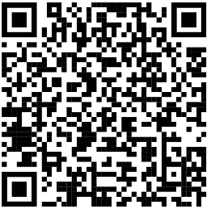
Scan for full list of Maths facts

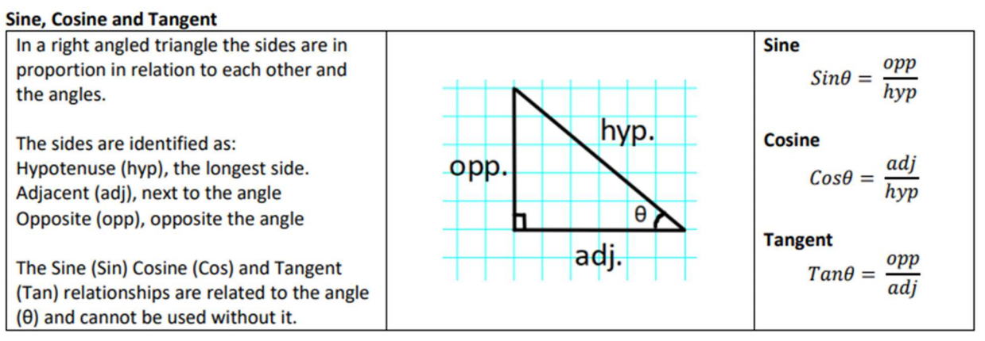
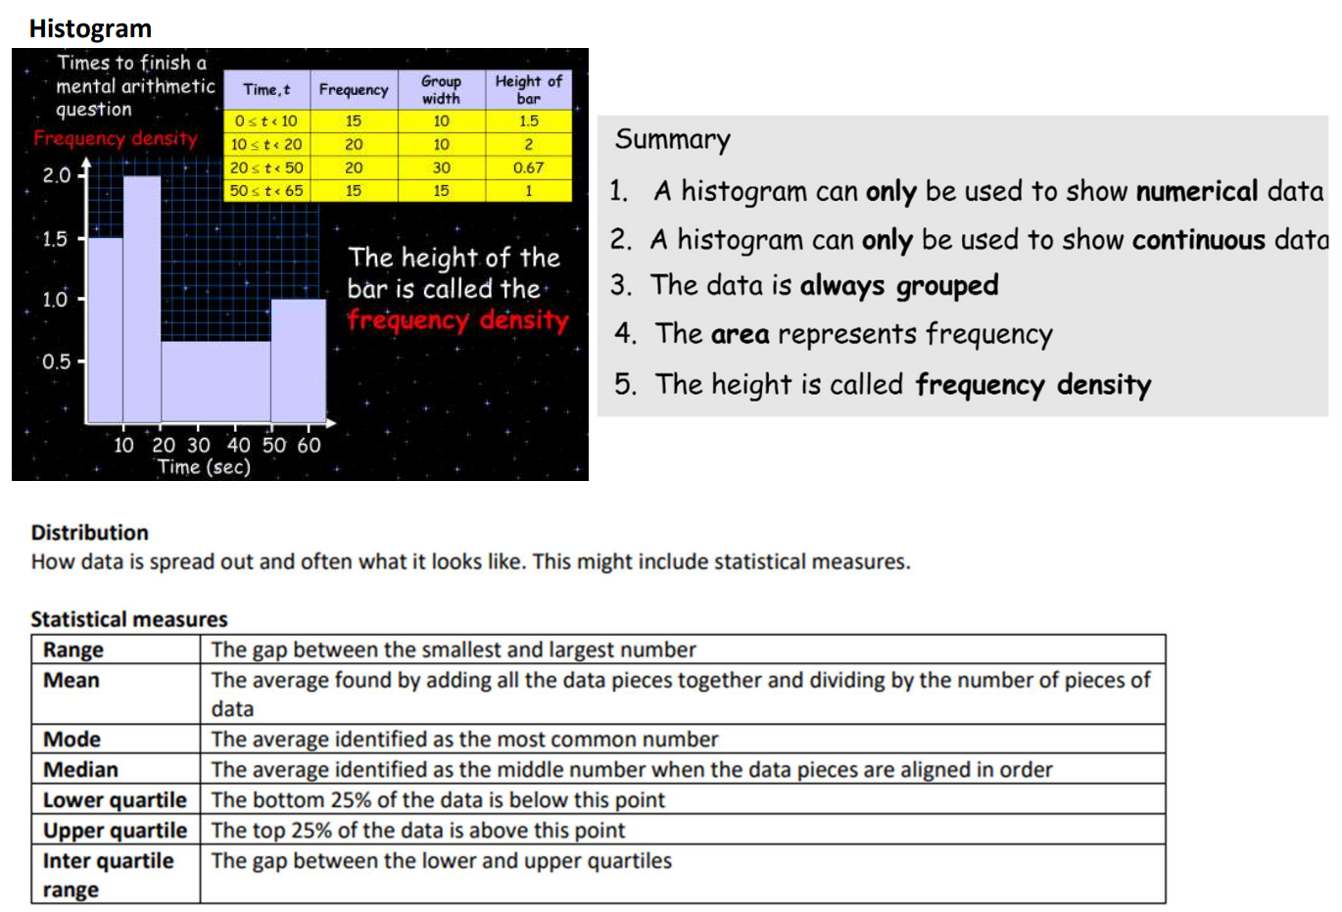
Autumn Term 2 Knowledge

