Knowledge Organiser
Autumn Term 2 Set 1 Year 10
Topic | Self-Assessment | Independent Learning and  homework tasks
 |  | MyMaths | CorbettMaths.com
Transformations; reflection, rotation, translation (3) |  | Shape, Transformations, …… | Video 272 – 275, 326
Transformations (4/6); enlargement |  | Shape, Transformations, …… | Video 104 - 109
Calculating averages from a (grouped) frequency table (5) |  | Data, Processing Data, Mean from Grouped Data 1 | Video 54 - 55
Calculating moving averages (6) |  | Statistics, Processing Data, Time Series
Constructing cumulative frequency tables and graphs (6) |  | Data, Presenting Data, Cumulative Frequency 1 | Video 153, 154
Calculating the median and interquartile range (6) |  | Data, Presenting Data, Cumulative Frequency 2 | Video 50 - 52
Constructing box and whisker plots (6) |  | Data, Presenting Data, Box and Whisker Plots | Video 149 - 150
Drawing scatter graphs and identifying types of correlation (4) |  | Data, Presenting Data, Scatter Graphs | Video 165 - 166
Drawing and interpreting distance time & velocity time (6/7) |  | Algebra, Graphs – Distance Time Graphs, Velocity Time Graphs | Video 171
Calculate lengths of arcs & areas of sectors (6) |  | Shape, Area & Perimeter – Arcs, Sectors, Segments | Video 58, 63
Calculate volume & surface area of prisms (4/5) |  | Shape, Vol & Surf Area – Nets & Surf Area, Vol of Prisms & Cylinder | Video 355 - 358

Stretch and Challenge:
- Practise UKMT Intermediate Maths Challenge Past papers on:
https://www.ukmt.org.uk/competitions/solo/intermediate-mathematical-challenge/archive
- Set up an account on parallel.org.uk website, using your school email address and use teacher code “ha52kh”
- Attend Puzzle Club one lunch time each week

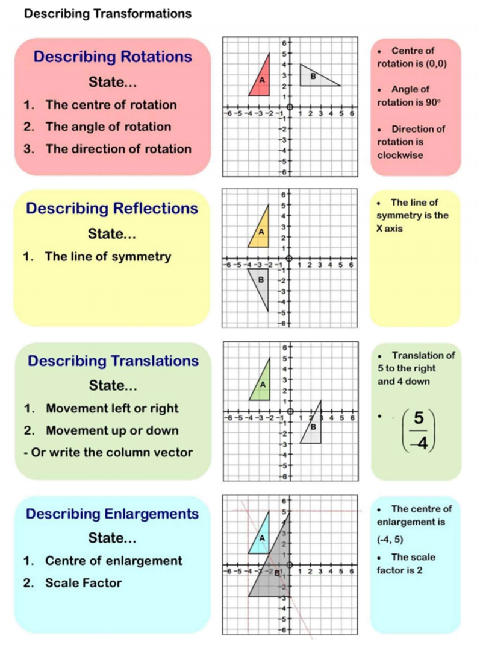
Autumn Term 2 Knowledge

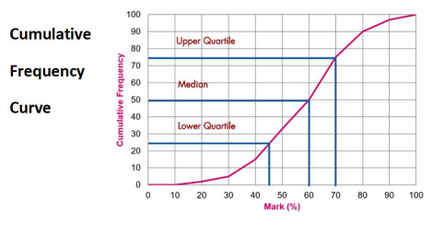
Scan for full list of Maths facts

