Knowledge Organiser
Lent Term 2 Set 2 Year 9

Topic |  |  |  | Independent Learning and homework tasks
 |  |  |  | MyMaths | CorbettMaths.com
Multiplying, dividing using indices |  |  |  | Number, Powers and roots, Indices 1 | Video 174
Understanding and using negative indices |  |  |  | Number, Powers and roots, Indices 2 | Video 175
Understanding and using fractional indices |  |  |  | Number, Powers and roots, Indices 3 | Video 173
Writing very large and small numbers in standard form, and vice-versa |  |  |  | Number, Standard Form | Video 300
Performing calculations in standard form |  |  |  | Number, Standard Form | Video 301-3
Simplifying ratio |  |  |  | Number, Ratio & Proportion Intro | Video 271a - d
Sharing quantities in a given ratio |  |  |  | Number, Ratio & Proportion, Ratio dividing 1 & 2 | Video 269
Solving problems using unitary method |  |  |  | Number, Ratio & Proportion, Unitary Method | Video 255a
Calculating averages from frequency and grouped frequency tables |  |  |  | Data, Processing data, Mean from Frequency tables | Video 54 & 55
Constructing and interpreting pie charts |  |  |  | Data, Presenting data, Drawing / Interpreting pie charts | Video 163 & 164
Constructing and interpreting frequency polygons |  |  |  | Data, Presenting data, Frequency Polygons | Video 155 & 156
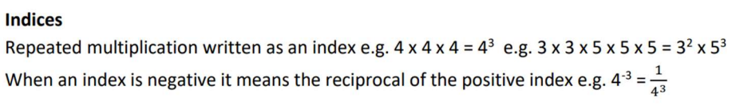
Lent Term 2 Knowledge

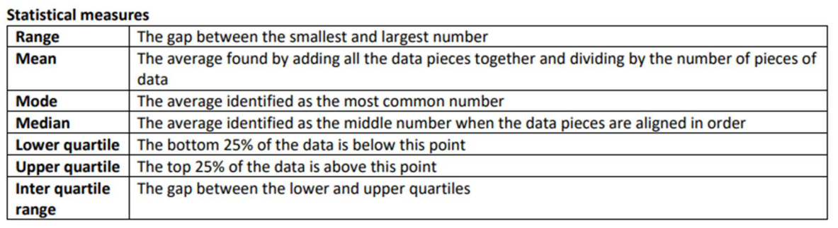
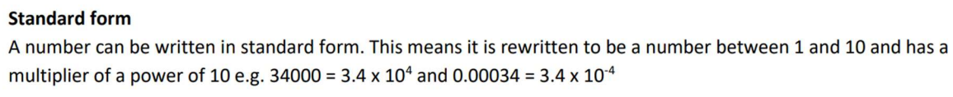
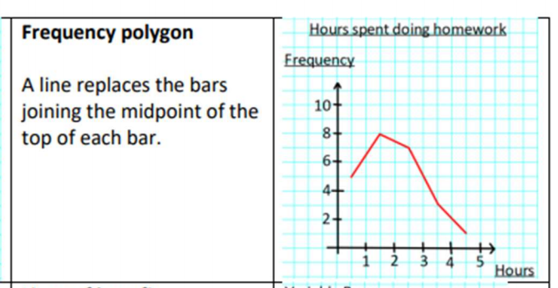

Scan for full list of Year 9 Maths facts

Maths Support Attend KS3 Maths Clinic every Friday lunch time for extra help and support.
Stretch and Challenge:
1) Practise UKMT Intermediate Maths Challenge Past papers on ukmt.org.uk
2) Set up an account on parallel.org.uk website, using your school email address and use teacher code “ha52kh”
3) Attend Puzzle Club one lunch time each week

