Bridging the Gap between GCSE and A level Chemistry Part 1 - April to May 2020
You should use your GCSE revision guide and your class notes to complete the following questions

- You can check your answers at the end of the document, with the answers section
- Don’t do the Questions until you have made good notes (see below)
- If you are unsure about anything, you can either contact your current Chemistry teacher or Dr. Berry

If you need to do more preparation……
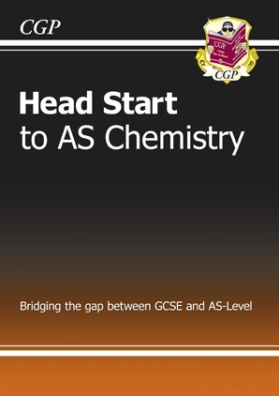
- Try ‘Head Start’ to AS Chemistry
- Currently free Kindle edition on Amazon
- ISBN 978 1 84762 116 0
- Only £4.95!

Make notes on the topics below, using your
GCSE Revision Guide
- Atomic Structure
- Atomic Number, Atomic Mass & Isotopes
- Balancing Equations
- Chemical Calculations (inc. Mr, Empirical Formula, Molecular formulas, calculating reacting amounts)
- Ionic Bonding (inc. explaining the properties of giant ionic structures)
- Ionic Formula
- Covalent Bonding (inc. explaining the properties of simple molecules &giant covalent structures)
- Metallic bonding (inc. explaining the properties of giant metallic substances)
Now try the questions!
- Crude Oil
- Cracking
- Polymers

Atomic Structure – Complete the table below
Particle
Relative Mass
Relative charge
Proton
Neutron
Electron

Atomic Number, Mass Number, Ions & Isotopes
Element or
ion
Symbol
Z
A
Protons
Electrons
Neutrons
Sodium
6
12
12
12
Chlorine
17
35
Chlorine
17
37
Lithium ion
Li
⁺
Chlorine ion
Cl
⁻
35.5
- Define an isotope.
- There are 2 isotopes of Cl. ³⁵Cl and ³⁷Cl. What would you observe when they react?

Balance the following equations
- Mg + O₂ MgO
- F₂ + KBr KF + Br₂
- Al + O₂ Al₂O₃
- Na + Cl₂ NaCl
- CuCO₃ CuO + CO₂
- K + O₂ K₂O
- C₄H₈ + O₂ CO₂ + H₂O
- Ba(OH)₂ + H₂SO₄ BaSO₄ + H₂O
- FeCl₃ + NaOH Fe(OH)₃ + NaCl
- HCl + Ba(OH)₂ BaCl₂ + H₂O

Chemical Calculations
- Calculate the M_{r} of: i) Br₂ ii) K₂CO₃ iii) (NH₄)₂SO₄ (3)
- Calculate the percentage of oxygen in K₂CO₃. (1)
- Define the terms empirical formula and molecular formula. (2)
- A hydrocarbon was found to contain 82.8% by mass of carbon. It has an M_{r} of 58. Find the empirical and molecular formulas of this compound.(3)
- 1 g of sulphur was burned forming 2.5 g of an oxide. Find the empirical formula of the oxide. (2)
- What mass of calcium oxide is formed from the decomposition of 180 g of calcium carbonate?
CaCO₃(s) CaO(s) + CO₂(g) (3)

Structure and Bonding
- Explain each of the following about melting and boiling points:
  - Simple molecular substances have low melting and boiling points. (2)
  - Giant covalent substances have very high melting and boiling points. (2)
  - Ionic substances have high melting and boiling points. (2)
  - Metals have quite high melting and boiling points. (2)
- Explain each of the following about electrical conductivity:
  - Simple molecular substances do not conduct at all. (1)
  - Giant covalent substances do not conduct, apart from graphite. (3)
  - Ionic substances conduct when melted or dissolved, but not when solid. (3)
  - Metals conduct as solids and when melted. (2)

What type of Structure is it?
 | Melting point  (⁰C) | Boiling  point (⁰C) | Electrical conductivity as solid | Electrical conductivity as liquid | Electrical conductivity as aqueous solution | Type of Structure (simple or giant)  & Bonding (covalent, ionic or metallic)
A | 54 | 120 | poor | poor | poor
B | 403 | 567 | good | good | not soluble
C | -210 | -196 | poor | poor | poor
D | 1610 | 2230 | poor | poor | not soluble
E | 615 | 876 | poor | good | good
F | 3727 | 4827 | good |  | not soluble
G | 56 | 342 | good | good | good
H | 934 | 1568 | poor | good | insoluble
I | -105 | -45 | poor | poor | good
Ionic Formula – Work out the ionic formula of the following:
Positive ions | Negative Ions
Silver, Ag⁺ | Nitrate, NO₃⁻
Ammonium, NH₄⁺ | Hydroxide, OH⁻
Lithium, Li⁺ | Chloride, Cl⁻
Sodium, Na⁺ | Oxide, O²⁻
Copper, Cu²⁺ | Carbonate, CO₃²⁻
Calcium, Ca²⁺ | Sulphate, SO₄²⁻
Iron (II), Fe²⁺
Iron (III), Fe³⁺
- silver nitrate
- iron (III) hydroxide
- ammonium chloride
- lithium oxide
- copper carbonate
- sodium sulphate
- iron (II) sulphate
- calcium hydroxide

Crude Oil
The alkanes are a homologous series of saturated hydrocarbons.
- What is a hydrocarbon? (2)
- What is a homologous series? (2)
- What is meant by the word saturated in this context? (1)
- Draw the structure of propane. (1)
- Octane is a straight chain alkane containing eight carbon atoms.
i) Write its molecular formula. (1) ii) Draw its structural formula. (1)
- Write a balanced equation for the complete combustion of propane.
(1)
- Write a balanced equation for the incomplete combustion of propane, where a toxic gas is formed. (1)

Cracking 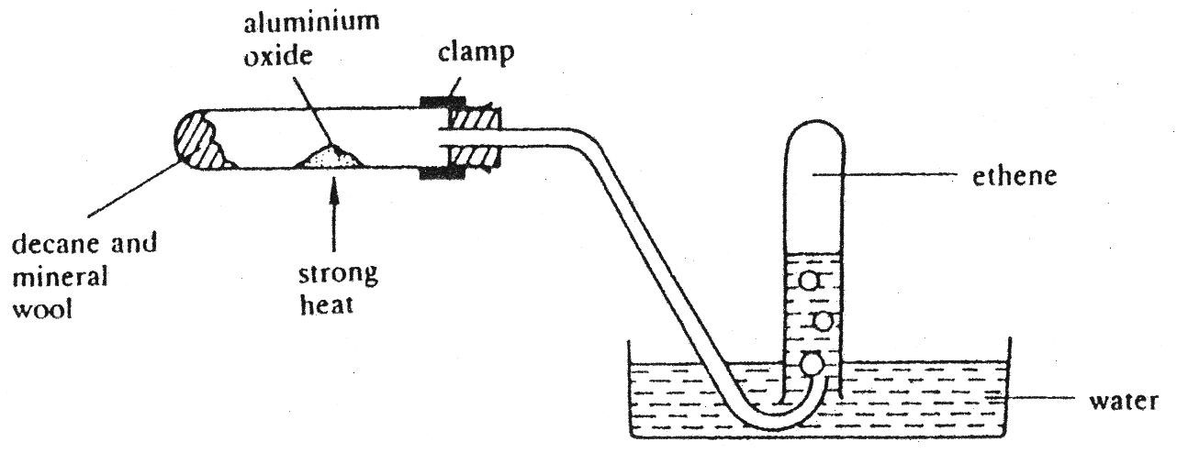
paraffin and
porous pot
- Cracking is a thermal decomposition reaction. Define thermal
decomposition. (2)
- What is produced when long alkanes are cracked and explain they are cracked. (3)
- Why is the porous pot used in Cracking? (1)
- Why would “suck back” have happened if the tube had not been removed at the end? (2)
- What happened when bromine water was added to the tube of gas collected? (1)

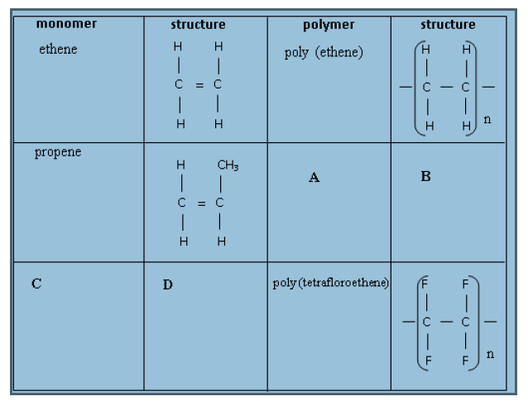
Polymers
1. Complete the table opposite
2. What is meant by the term ‘Monomer’?
3. What is meant by the term ‘Polymer?
4. What is the formula of
tetrafluoroethane?
5. What feature allows these molecules to be polymerised?

Answer section
Remember, if you are still unsure after checking your answers, speak to your Chemistry Teacher!

Atomic Structure – Complete the table below
Particle | Relative Mass | Relative charge
Proton | 1 | +1
Neutron | 1 | None
Electron | ¹/₁₈₄₀ or neglible | -1

Atomic Number, Mass Number, Ions & Isotopes
Element or ion | Symbol | Z | A | Protons | Electrons | Neutrons
Sodium | Na | 11 | 23 | 11 | 11 | 12
Carbon | C | 6 | 12 | 6 | 6 | 6
Magnesium | Mg | 12 | 24 | 12 | 12 | 12
Chlorine | Cl | 17 | 35 | 17 | 17 | 18
Chlorine | Cl | 17 | 37 | 17 | 17 | 20
Lithium ion | Li⁺ | 3 | 7 | 3 | 2 | 4
Chlorine ion | Cl⁻ | 17 | 35.5 | 17 | 18 | 18.5
1. Define an isotope. Same number of protons and electron, but a different number of neutrons 2. There are 2 isotopes of Cl. ³⁵Cl and ³⁷Cl. What would you observe when they react? There is no difference because both isotopes have the same number of electrons in their outer shell

Balance the following equations
- 2Mg + O₂ 2MgO
- F₂ + 2KBr 2KF + Br₂
- 4Al + 3O₂ 2Al₂O₃
- 4) 2Na + Cl₂ 2NaCl
- CuCO3 CuO + CO2 already balanced!
- 4K + O₂ 2K₂O
- C₄H₈ + 6O₂ 4CO₂ + 4H₂O
- Ba(OH)₂ + H₂SO₄ BaSO₄ + 2H₂O
- FeCl₃ + 3NaOH Fe(OH)₃ + 3NaCl
- 2HCl + Ba(OH)₂ BaCl₂ + 2H₂O

Chemical Calculations 1
1) a) Calculate the M_{r} of: i) Br₂ 160 ii) K₂CO₃ 132 iii) (NH₄)₂SO₄ 134
b) Calculate the percentage of oxygen in K₂CO₃. (16 x 3) / 132 = 0.36 x 100 = 36% 2) a) Define the terms empirical formula: Simplest ratio of atoms molecular formula: Actual number of Atoms
b) A hydrocarbon was found to contain 82.8% by mass of carbon. It has an M_{r} of 58. Find the empirical (see working below) C₂H₅ and molecular formulas of this compound. The empirical formula has a mass of 29.
58/29 = 2, so we need double the molecular formula C₄H₁₀

 | C | H
Mass (g) | 82.8g | 100 – 82.8 = 17.2
Divide by Mr | 82.8/12 | 17.2/1
= | 6.9 | 17.2
Divide by smallest no. | 6.9/6.9 = 1 | 17.2 / 6.9 = 2.5
Answer | 2C | 5H

Chemical Calculations 2
c) 1 g of sulphur was burned forming 2.5 g of an oxide. Find the empirical
formula of the oxide. (2)
 | S | O
Mass (g) | 1g | 2.5 - 1= 1.5
Divide by Mr | 1/32 | 1.5 / 16
= | 0.03 | 0.09
Divide by smallest no. | 0.03/0.03 = 1 | 0.03 / 0.09 = 3
Answer | 1 S | 3 O
3)What mass of calcium oxide is formed from the decomposition of 180 g of calcium carbonate?
CaCO₃(s)  CaO(s) + CO₂(g)
nCaCO₃ = M / Mr = 180 / (40 + 12 + 16 x 3) = 1.8 moles nCaCO₃ = nCaO = 1.8 moles
M CaO= n x Mr = 1.8 x (40 + 16) = 100.8g

Structure and Bonding Question 1
Explain each of the following about melting and boiling points:
- Simple molecular substances have low melting and boiling points. Weak forces (1) between the molecules (not atoms!) (1)
- Giant covalent substances have very high melting and boiling points.
Many strong (1) covalent bonds between the atoms (not molecules!) (2)
- Ionic substances have high melting and boiling points.
Ionic compounds are held together by many strong electrostatic attractions or attractions between oppositely charged ions(1)
Lots energy is needed to overcome them (1) (no mention of molecules!)
- Metals have quite high melting and boiling points.
Metals are held together by many strong electrostatic attractions or attractions between positive ions and negative electrons(1)
Lots of energy is needed to overcome these attractions(1) (no mention of molecules!)

Structure and Bonding Question 2
Explain each of the following about electrical conductivity:
- Simple molecular substances do not conduct at all.
No free electrons or movement of charge (1)
- Giant covalent substances do not conduct, apart from graphite.
No free electrons or movement of charge (1)
In graphite only 3 electrons are used in bonding (1)
Leaves a free electron to conduct electricity (1)
- Ionic substances conduct when melted or dissolved, but not when solid.
When solid the ions are in fixed positions, so there is no movement of charge (1) when the ions are dissolved in water or melted they are free to move (1)
This allows charge to flow (1)

No mention of moving electrons – there are no free electrons
d) Metals conduct as solids and when melted. Have delocalised / free moving electrons (1) charge can be carried through the structure (1)
What type of Structure is it?
 | Melting point  (C) | Boiling  point (C) | Electrical conductivity as solid | Electrical conductivity as liquid | Electrical conductivity as aqueous solution | Type of structure & bonding
A | 54 | 120 | poor | poor | poor | Simple molecular, covalent
B | 403 | 567 | good | good | not soluble | Giant metallic
C | -210 | -196 | poor | poor | poor | Simple molecular, covalent
D | 1610 | 2230 | poor | poor | not soluble | Giant covalent
E | 615 | 876 | poor | good | good | Giant ionic
F | 3727 | 4827 | good |  | not soluble | Giant metallic
G | 56 | 342 | good | good | good | Giant ionic
H | 934 | 1568 | poor | good | insoluble | Giant ionic
I | -105 | -45 | poor | poor | good | Simple molecular, covalent
Ionic Formula – Work out the ionic formula of the following:
- silver nitrate  - iron (III) hydroxide  - ammonium chloride  - lithium oxide  - copper carbonate  - sodium sulphate  - iron (II) sulphate  - calcium hydroxide | - AgNO₃  - Fe(OH)₃  - NH₄Cl  - Li₂O  - CuCO₃  - Na₂SO₄  - FeSO₄  - Ca(OH)₂

Crude Oil
- What is a hydrocarbon? Only – 1 Compound containing H & C - 1
- What is a homologous series? series of compounds that have similar properties - 1 and the same general formula. - 1
- What is meant by the word saturated in this context? No C=C bond
- Draw the structure of propane. 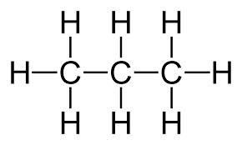
- Octane is a straight chain alkane containing eight carbon atoms.
i) Write its molecular formula. C₈H₁₈ ii) Draw its structural formula.
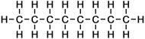
iii) f) Write a balanced equation for the complete combustion of propane.
C₃H₈ + 4.5O₂ 3CO₂ + 4H₂O to get rid of halves, double everything! 2C₃H₈ + 9O₂ 6CO₂ + 8H₂O
g) Write a balanced equation for the incomplete combustion of propane, where a toxic gas is formed.
C₃H₈ + 3.5O₂ 3CO + 4H₂O to get rid of halves, double everything! 2C₃H₈ + 7O₂ 6CO + 8H₂O

Cracking
- Cracking is a thermal decomposition reaction. Define thermal decomposition.
Thermal – using heat (1)
To break down the compound (1)
- What is produced when long alkanes are cracked and explain they are cracked. Short chain alkane (1) Short chain Alkenes (1) These
molecules are in higher demand than long chain alkanes (1)
- Why is the porous pot used in Cracking?Catalyst (1)
- Why would “suck back” have happened if the tube had not been removed at the end? The hot air in the heated test tube would have contracted (1) this would have sucked cold water into the hot test tube, causing it to shatter (1)
- What happened when bromine water was added to the tube of gas collected? Turned from orange to colourless (NOT clear!) (1)
- Complete the table opposite
- What is meant by the term ‘Monomer’?
Identical small molecules, than often contain a C=C bond
- What is meant by the term ‘ Polymer?
Large molecule made up of many
identical repeat units called monomers
- What is the formula of tetrafluoroethane? C₂H₄
- What feature allows these molecules to be polymerised? C=C double bond
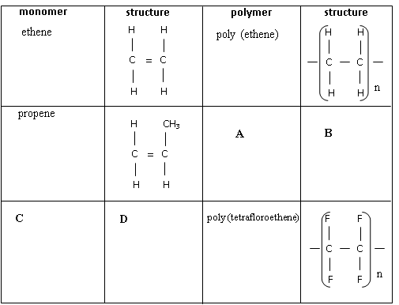
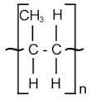
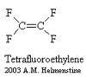
Polymers
polypropene
Tetrafluoro
ethane

