Topic |  |  |  | Independent Learning and homework tasks
 |  |  |  | MyMaths | CorbettMaths.com
Finding a percentage of a quantity and one quantity as a percentage of another. |  |  |  | Number, Percentages | Video 235
Increase a quantity by a given percentage with and without a calculator. |  |  |  | Number, Percentages | Video 234, 235
Calculate percentage increase and decrease, profit & loss. |  |  |  | Number, Percentages | Percentage Change video 233
Area and perimeter of 2D shapes and compound shapes |  |  |  | Shape, Area and Perimeter | Videos 42 – 49,  Videos 241 - 243
Volume of a prism |  |  |  | Shape, Volume and Surface Area | Videos 355 – 7
Surface Area of a prism |  |  |  | Shape, Volume and Surface Area | Videos 309 - 312
Converting between different metric units of length, area and volume |  |  |  | Shape, Converting units | Videos 349d, e, f
Compound Measure – speed, density and pressure |  |  |  | Shape, Measures, Speed / Density | Speed Video 299  Density Video 384  Pressure Video 385
Using BODMAS for order of operation |  |  |  | Algebra, Expressions and Formulae, Order of Operations | Video 211
Using a calculator for complex calculations |  |  |  | Number, Calculators | Video 352
Round to a given number of decimal places |  |  |  | Number, Estimating and Accuracy | Video 276 - 8
Round to a given number of significant figures |  |  |  | Number, Estimating and Accuracy | Video 279a
Finding angles on parallel lines |  |  |  | Shape, Angles, Angles on Parallel lines | Video 25
Interior and Exterior Angles of a polygon |  |  |  | Shape, Angles, Interior Exterior Angles / Sum of angles of a polygon | Video 32

Lent Term 1 Knowledge

Order of operations (BIDMAS) Scan for full list of Maths Knowledge
There is an order to operations:
B (Brackets) - any calculation within a bracket is completed first
I (Indices) – any term with a power is completed second
D (Division) – any division is completed third
M (Multiplication) – any multiplication is completed next
A (Addition) – any addition is completed next in a left to right order
S (Subtraction) – any subtraction is completed last and in a left to right order

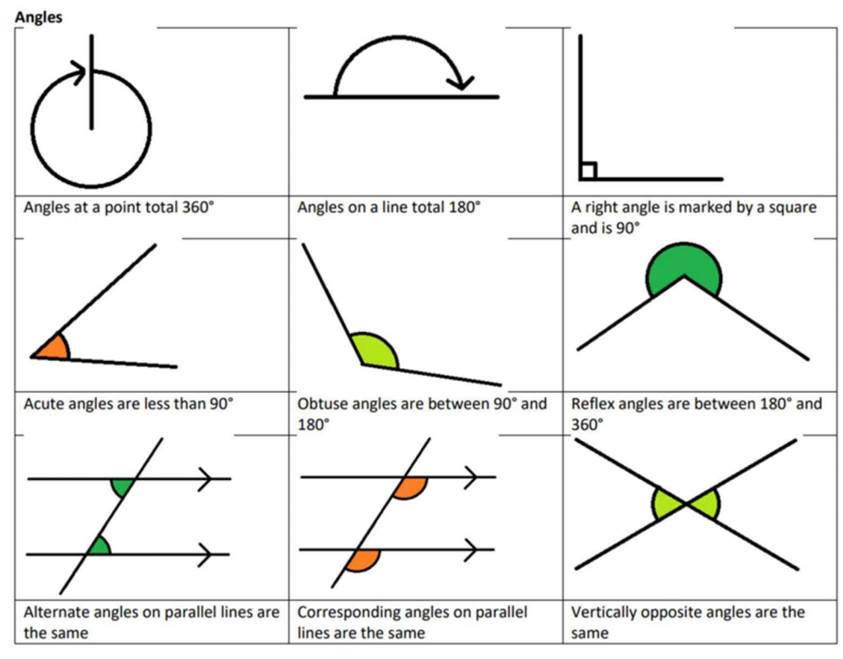

Maths Support
Attend KS3 Maths Clinic every Friday lunch time for extra help and support.
Stretch and Challenge:
- Set up an account on parallel.org.uk website, using your school email address and use teacher code “ha52kh”
- Attend Puzzle Club one lunch time each week

