Topic |  |  |  | Independent Learning and homework tasks
 |  |  |  | MyMaths | CorbettMaths.com
Simplifying ratio and dividing a quantity by a given ratio |  |  |  | Number, Ratio and Proportion, Ratio dividing 1 | Ratio: simplifying/express as fraction or %/sharing the total  Videos 269-270
Finding and recognising factors, multiples and primes |  |  |  | Number, Powers and Roots | Number: factors (Video 216)/multiples (Video 220)/ prime numbers (Video 225)
Finding HCF and LCM |  |  |  | Number, Powers and Roots | Number: common multiples/LCM/common factors/HCF  Videos 218-219
Drawing Prime Factor Trees |  |  |  | Number, Powers and Roots | Number: product of primes/product of primes (LCM/HCF)  Videos 224-225
Venn Diagrams to illustrate prime factor decomposition |  |  |  |  | Additional Topics: Venn diagrams – Video 380
Use and interpret algebraic notation |  |  |  | Algebra, Introduction to Algebra | Algebra: notation – Video 19
Forming simple expressions |  |  |  | Algebra, Expressions and Formulae, Rules and Formulae | Algebra: expressions – forming – Video 16
Simplifying expressions |  |  |  | Algebra, Algebraic Manipulation, simplifying 1 (and 2 extension) | Algebra: collecting like terms – Video 9
Algebraic substitution |  |  |  | Algebra, Expressions and formulae, substitution | Algebra: substitution – Video 20
Expanding single brackets |  |  |  | Algebra, Algebraic Manipulation, single brackets | Algebra: expanding brackets – Video 13
Knowledge Organiser
Autumn 2 Half Term Year 7

Stretch and Challenge:
- Practise UKMT Junior Maths Challenge Past papers on:
https://www.ukmt.org.uk/competitions/solo/junior-mathematical-challenge/archive
- Set up an account on parallel.org.uk website, using your school email address and use teacher code “ha52kh”

Michaelmas Term 2 Knowledge

Types of numbers:
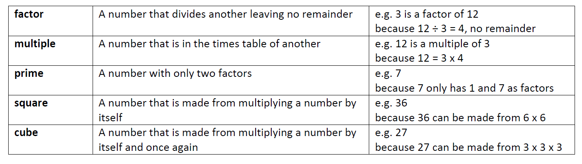
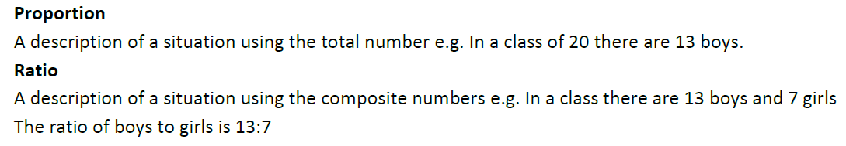

Scan for full list of Year 7 topics

